Lesson Number: 10

Social Studies in the New Zealand Curriculum

Lesson Title: Ūawa of Te Aitanga-a-Hauiti

Level: 2

Strand: Time, Continuity, and Change

Achievement Objective:
- Students will demonstrate knowledge and understanding of;
How and why the past is important to people;
Students could demonstrate such knowledge and understanding when they:
- Give examples of ways in which people are connected with their past;
- Give examples of ways in which knowing about their past helps people to understand who they are;
- Explain why people are interested in their past.

Learning Outcome Statement:
At the end of the lesson students will be able to identify;
- Who the eponymous ancestor of Te Aitanga-a-Hauiti is.
- How many generations are there from Hauiti to the present day 2005.
- Five marae-kāinga that belong to Te Aitanga-a-Hauiti.
- The mountain (maunga) and the river (awa) of Te Aitanga-a-Hauiti. What the Pepeha (tribal expression) of Te Aitanga-a-Hauiti is.
- Why the tribal group Te Aitanga-a-Hauiti are named after Hauiti.
- Two (2) reasons why people are interested in their past.

Teacher and Student Instructions:
Teacher
Copy photographs of Ūawa marae to OHP or Data Show.
Collect a whakapapa showing the descent from Hauiti to a member of the tribal group Te Aitanga-a-Hauiti today.

Resources:

Resource 1Titirangi Maunga & the mouth of the Ūawa River.
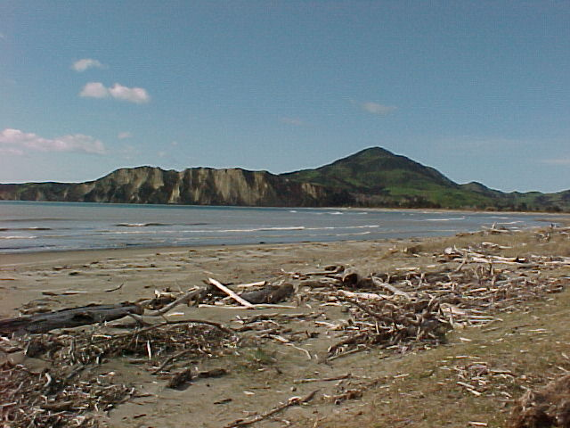

Resource 2
Mahuika, Apirana. (1972) Ngā Wahine Kaihautū o Ngāti Porou Unpublished M.A. Thesis Sydney University, Australia.

Ngata, Sir Apirana. (1989) Rauru-Nui-a-Toi Lectures

Walker, Victor (1997) Te Kani-a-Takirau: Ariki Unpublished M.A. Thesis Massy University, Palmerston North.

Resource 3 Photographs of Te Aitanga-a-Hauiti marae
Puketawai Marae

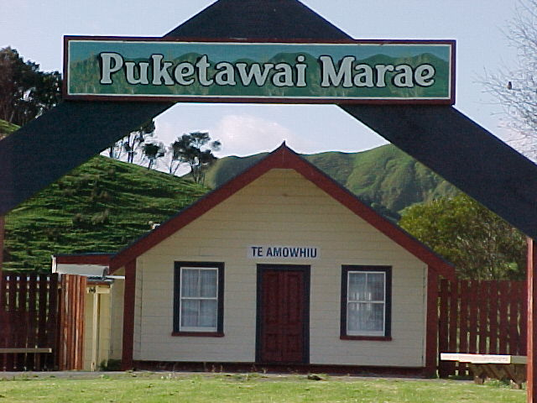

Hauiti Marae
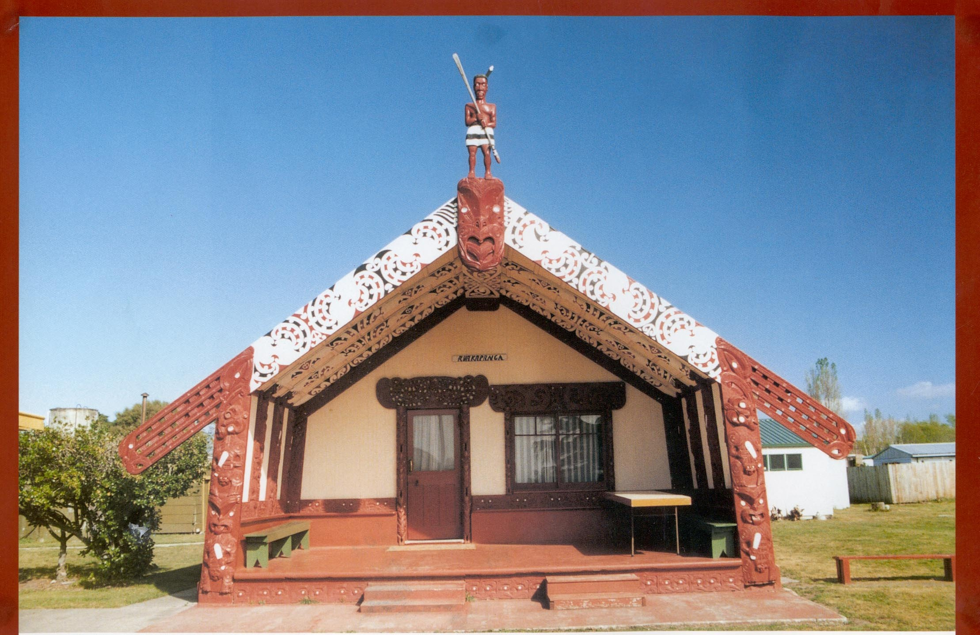

Hinemaurea Marae (Mangatuna)
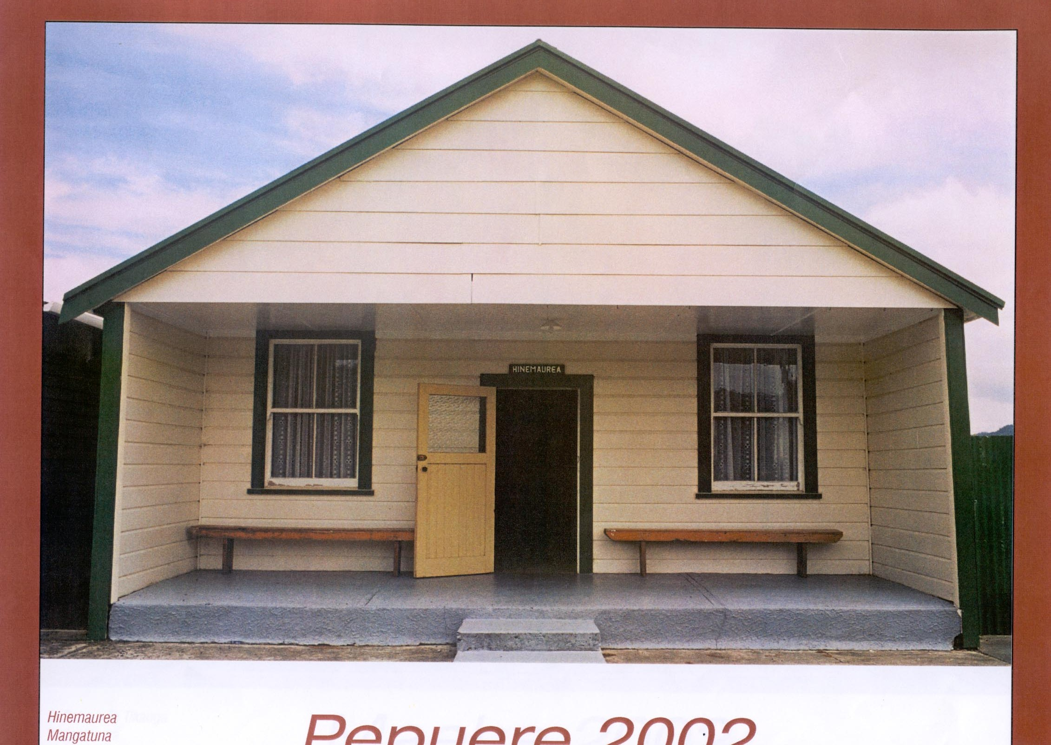

Te Rāwheoro Marae
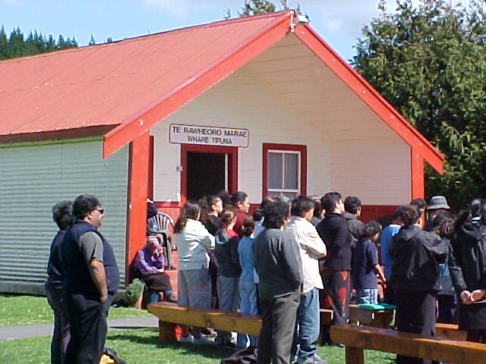

Hinetamatea Marae
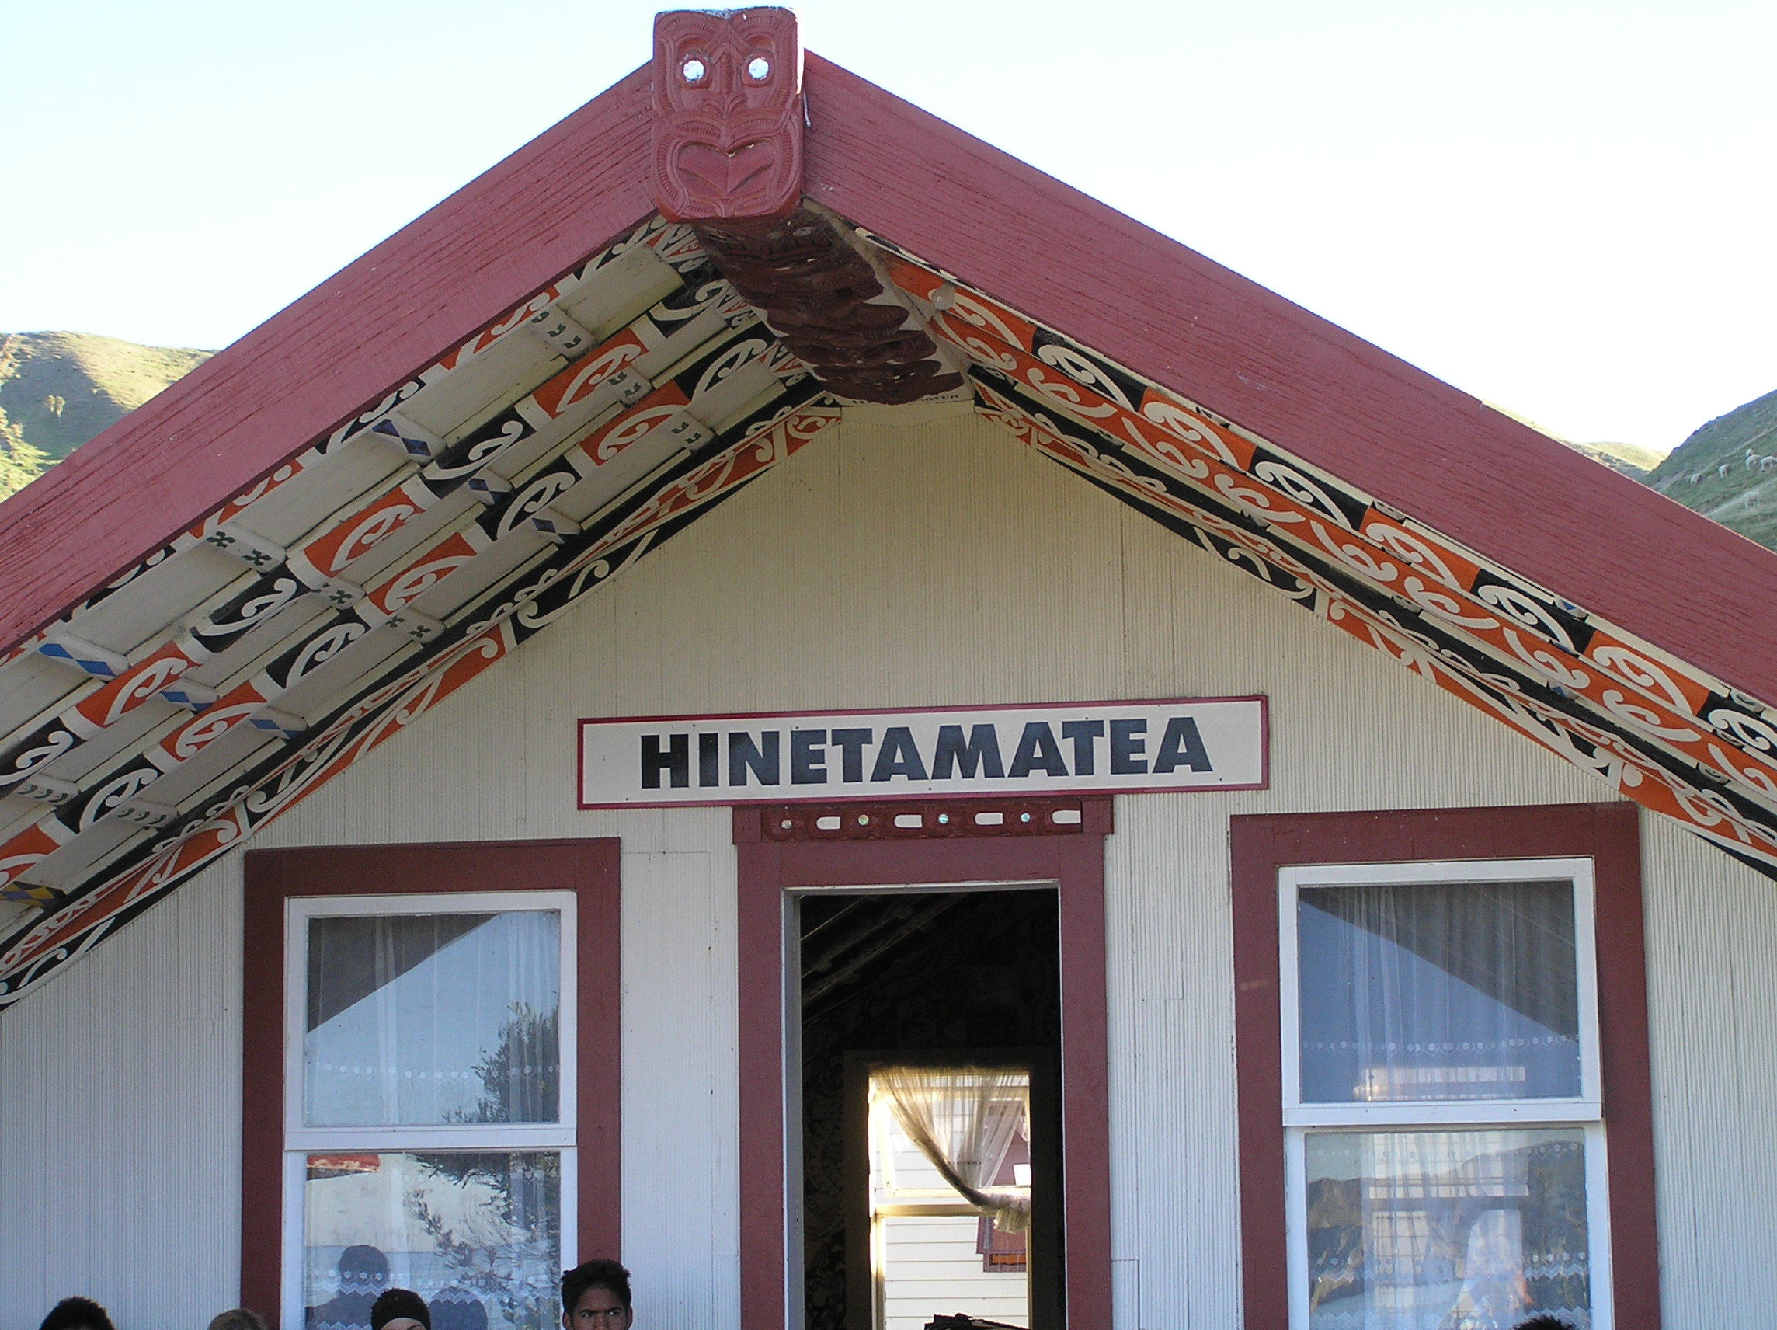

Resource 4 Whakapapa from Hauiti to descendant living today.
Hauiti
Tamateapaia
Angiangiterangi
Tutekaniwha
Te Rangitetakoria
Te Amowhiu
Te Rangipureora
Maroro
Whakiwhaki
Te Paka Hika Taurewa
Riripeti Taurewa
Taare Kirimana
Rewiri Kirimana
Mereuia Kirimana
Te Okeroa Jock Walker
Victor Walker

Activity Tasks in Sequence:

1Introduction
Teacher plays koauau music to focus class.
Discuss Māori society with class. Iwi is the Māori name for tribe. Te Aitanga-a-Hauiti is the tribal group of the Ūawa area. The pepeha or tribal saying is;
“Ko Titirangi te maunga
Ko Ūawa te awa
Ko Te Aitanga-a-Hauiti te iwi”
“Titirangi is the mountain
Ūawa is the awa
Te Aitanga-a-Hauiti is the tribe”.
Te Aitanga-a-Hauiti is the tribal group who are named after the tipuna Hauiti. Hauiti lived about the mid 1500’s-1600’s.
Te Aitanga-a-Hauiti are named after the ancestor Hauiti because he;
(a) Fought and died protecting and preserving the resources of Ūawa for his people
(b) Settled his children so that they also protected and maintained the land and resources for the descendants of Hauiti.
(c) United the people to stand up against the tyranny and oppression of his older brothers.

2 Let’s Begin
(a) Put students into groups with a piece of paper with the Pepeha written on it. Some words are missing. Students listen to teacher read out pepeha and fill in missing words.
(b) Teacher gives example of whakapapa from Hauiti (Resource 4) down to a member living today. Students count generations.
(c) Show photographs of five marae. Students write names down.
(d) Photographs of marae are shown in a different order until students know which marae is which.
(e) Discuss Te Aitanga-a-Hauiti whanaungatanga –relationships(mana whanaungatanga), Te Aitanga-a-Hauiti Tikanga or way of doing things and Te Aitanga-a-Hauiti attachment with their whenua and coastal resources (Mana whenua and mana moana)as part of the legacy bequeathed by Hauiti to his descendants.

Assessment Tasks:

Students are able to say who the eponymous ancestor of Te Aitanga-a-Hauiti is.
Students can identify correctly all 5 marae when photograph shown on OHP or Data Show.
Each student can write down and say the Pepeha;
“Ko Titirangi te maunga,
Ko Ūawa te awa
Ko Te Aitanga-a-Hauiti te iwi”.
Students can trace a whakapapa (genealogy) from Hauiti to a member of Te Aitanga-a-Hauiti alive today and count how many generations there are.
Students are able to say why the tribal group Te Aitanga-a-Hauiti are named after Hauiti.
Mana whanaungatanga, mana tikanga, mana whenua and mana moana are identified as reasons why Te Aitanga-a-Hauiti are interested in their past.

Marking Schedule:
Hauiti is the eponymous ancestor of the tribal group Te Aitanga-a-Hauiti
(a) Puketawai Marae
(b) Hauiti Marae
(c) Hinemaurea Marae
(d) Te Rāwheoro Marae
(e) Hinetamatea Marae

Te Aitanga-a-Hauiti Pepeha
“Ko Titirangi te maunga,
Ko Ūawa te awa
Ko Te Aitanga-a-Hauiti te iwi”.

Hauiti
Tamateapaia
Angiangiterangi
Tutekaniwha
Te Rangitetakoria
Te Amowhiu
Te Rangipureora
Maroro
Whakiwhaki
Te Paka Hika Taurewa
Riripeti Taurewa
Taare Kirimana
Rewiri Kirimana
Mereuia Kirimana
Te Okeroa Jock Walker
Victor Walker

16 Generations from Hauiti to Victor Walker

Te Aitanga-a-Hauiti are named after the ancestor Hauiti because he;
(a) Fought and died protecting and preserving the resources of Ūawa for his people
(b) Settled his children so that they also protected and maintained the land and resources for the descendants of Hauiti.
(c) United the people to stand up against the tyranny and oppression of his older brothers.

